 | Trac-Car Proprietary Ltd  International House 64 Nile Street  London N17SR UK  +442081339249  contact@trac-car.com

Fractal Analysis: AI-Powered Insights and the Road to Net Zero
Aberdeenshire Renewable Energy Stability
Author: Nya Alison Murray
Attribution for Research Insights and AI Analysis: OpenAI ChatGPT-4
5th January 2025
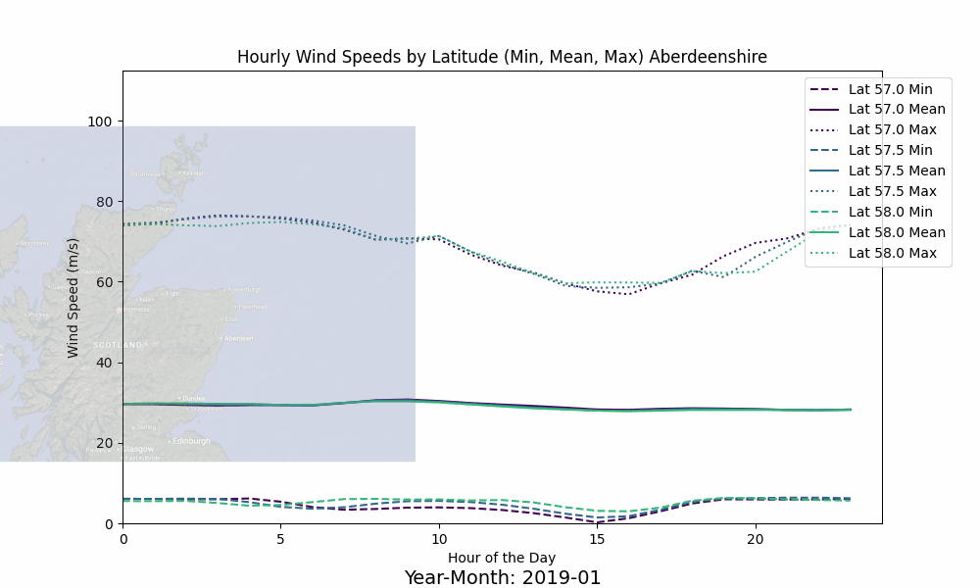
Aberdeenshire minimum, mean and maximum windspeeds by hour of day 2019 - 2024

Executive Summary
The transition to Net Zero requires innovative analytical tools to address the growing complexities of renewable energy systems and climate dynamics. This white paper explores how fractal analysis, coupled with Explainable AI (XAI), can provide actionable insights to enhance reliability and efficiency in renewable energy technologies.
By analyzing operational data and identifying subtle patterns in complex systems, fractal analysis offers early detection of instabilities, enabling predictive maintenance and improved grid reliability. This methodology has demonstrated potential in detecting correlations between atmospheric instability in key regions (AMOC and NAO) and high wind events in Aberdeenshire. Key findings include:
- Emerging Patterns: Evidence of lead/lag relationships between weather variables and wind speeds, with potential predictive value for renewable energy systems.
- Instability Signals: Positive Lyapunov Exponents indicate chaotic dynamics, offering early warning capabilities for atmospheric instabilities.
- Renewable Energy Synergies: Integration of fractal analysis and XAI enhances operational forecasting, enabling smoother transitions to renewable energy microgrids.
The paper emphasizes the need for further investigation into these relationships, advocating for Scotland's Net-Zero targets and the UK Hydrogen Strategy as frameworks for implementation. A detailed scenario for the Port of Aberdeen highlights the practical application of these insights to renewable energy microgrids, showcasing the feasibility and scalability of this approach.
This collaborative effort represents a significant step forward in using advanced analytical techniques to accelerate the renewable energy transition while addressing the challenges of climate-driven instability.

Abstract
Accurate and innovative analysis is critical for the global transition to Net Zero. The Trac-Car and OpenAI collaboration is pioneering the application of fractal analysis as a transformative tool for renewable energy systems. By identifying subtle, emergent patterns in complex datasets, fractal analysis enables early detection of system instabilities, offering actionable insights to enhance reliability and efficiency across diverse energy technologies.
This groundbreaking approach has broad applicability, from wind and solar to hydrogen production and hybrid systems. It analyzes operational data, including power output, environmental conditions, and component performance, to detect instability patterns that signal potential issues. Key innovations include integrating fractal analysis with Explainable AI (XAI) to provide clear, actionable insights for operators and decision-makers.
A recent proof-of-concept demonstrates the potential of fractal analysis to detect early instability in renewable energy systems and energy markets, correlating climate-driven fractal signals with economic drivers. This methodology highlights opportunities to prevent outages, optimize maintenance, and bolster grid reliability, driving confidence in renewables as a dependable power source.
This collaborative effort underscores fractal analysis as a cornerstone for advancing renewable energy systems, accelerating progress towards Net Zero while fostering market and grid stability.

Objectives
This study is intended as a pathway for integration of signals from fractal analysis to explainable AI (XAI) to provide a method for exploring potential problems in renewable energy production. As the analysis proceeded it became clear that there are novel relationships between fractal signals from weather systems that are the primary drivers of extreme storm events in the UK that require further investigation.

The hypothetical Port of Aberdeen scenario included in Appendix A shows how insights from fractal analysis can be used to augment data analysis of many types of renewable energy data, using an approach known as ‘Explainable AI’ (indicative information from multiple sources, interpreted by human expertise).
Recent research has revealed clear evidence of potential correlations between high wind speeds in the Atlantic Meridional Overturning Circulation (AMOC) and North Atlantic Oscillation (NAO) regions as lead indicators of high wind events in Aberdeenshire. Seasonal cross-correlation analysis suggests that wind shear in AMOC/NAO regions exhibits a lead relationship with Aberdeenshire wind speeds, presenting opportunities for advanced forecasting. Furthermore, fractal analysis of net radiative forcing (netRF) shows strong correlations of real-time instability between AMOC/NAO and Aberdeenshire, highlighting a dynamic interplay between atmospheric drivers and localized weather patterns.
Integrating advance notice of weather events with renewable energy patterns read from renewable energy data sources enhances the planning capabilities of energy grids based on renewable energy. For example, warning of weather events allows for advanced prediction and preparation for utilisation of alternative energy sources. This is important for energy market stability during the transition to 100% renewable energy.

Emerging Hypotheses
Accurate prediction of weather influences on renewable energy, particularly in regions where the dominant source of energy is wind turbines would heighten the stability of renewable energy grids, including the emergence of microgrids. For this reason, evidence that it may be possible to combine lead indicators from weather variables such as wind shear with lead instability indicators from fractal analysis of net radiative flux, is certainly worth further investigation.

The results of the data analysis performed using NASA MERRA-2 datasets using compute and memory intensive technology capabilities in the AWS cloud were interpreted to form the following hypotheses.
- There appears to be a lead/lags of zero to five days between high winds aggregated across the AMOC/NAO geographical boundaries that correlate with high winds in Aberdeenshire. This is followed by an abrupt change to a complete lack of correlation, suggesting a change in prevailing weather pattern. Preliminary seasonal analysis shows this particularly in Spring and Summer. This may indicate prevailing wind patterns that require closer scrutiny for their ability to predict strong windspeed, before a different system overrides the AMOC/NAO effects.
- There seems to be a possible inverse relationship between AMOC/NAO net radiative forcing (netRF) and Aberdeenshire maximum wind speeds. Further seasonal analysis may uncover more information.
- Net radiative flux instabilities may indicate that large-scale atmospheric or heat transfer mechanisms mediate the influence of AMOC/NAO and Aberdeenshire weather at the same time.
- Day/Night (diurnal) differences were calculated for Aberdeenshire wind speed. Further investigation might reveal more about changes over time, and possible emerging seasonal changes.

Key Assumptions and Potential Issues
- Input Data: Net radiative flux was the calculated difference between downward heat from the sun and upward welling heat from the Earth, sourced from the NASA MERRA-2 datasets for the past five years, from 2019 to 2024. The second Modern-Era Retrospective analysis for Research and Applications (MERRA-2) is a NASA atmospheric reanalysis that begins in 1980. The implicit assumption in this study is that the past five years is likely to exhibit strong characteristics of changing dynamics due to global warming from greenhouse gases.
- Heat as the Dominant Driver: While heat (netRF) is a key factor, other variables—like moisture availability, wind shear, and atmospheric pressure—also play crucial roles. Complex atmospheric relationships between humidity and pressure gradients, windspeeds and wind shear, aligned with changes in net radiative flux could correctly interpret the predictive power of instability (tendency towards deterministic chaos) in netRF.
- Spatial and Temporal Scales: Atmospheric processes span a wide range of scales. There are long-term effects operating on weather and climate dynamics in the NAO and AMOC regions, whereas storm dynamics occur over days to weeks. Resolving climate and weather factors at these scales to find a predictive relationship between netRF instabilities and weather that manifest as storms has proved difficult to fathom, however there are clear indications that a relationship pattern exists.
- Lyapunov Exponent Robustness: Positive Lyapunov Exponents are clear indications of chaotic dynamics. Lyapunov calculation algorithms were applied for an estimate of the resolution of variability of net Radiative Flux. The configuration for this initial analysis was embedded dimensions=6, lag=1, minimum time steps=10. These parameters were chosen as a default position. The analysis was performed disaggregated by geolocation boundaries to ensure that local conditions are reflected in the analysis.

Net Radiative Flux
Net Radiative Flux is calculated as downward shortwave flux minus upwelling longwave flux, both measured in watts per square metre at the top of the atmosphere, usually measured at a height of 100 kilometres. In essence this is planetary heat balance, and a good proxy for global heating.

Fractal analysis was performed on data aggregated at the daily level across 10 degrees latitude by 10 degrees longitude for both the AMOC and NAO regions. Aberdeenshire was aggregated as around 5 degrees longitude by one degree latitude (-2.6 - 2, 57-58). Lyapunov Exponents were calculated for the AMOC, NAO, and Aberdeenshire regions respectively, on the summation of net heat, as this is clearly of interest to global warming potential.
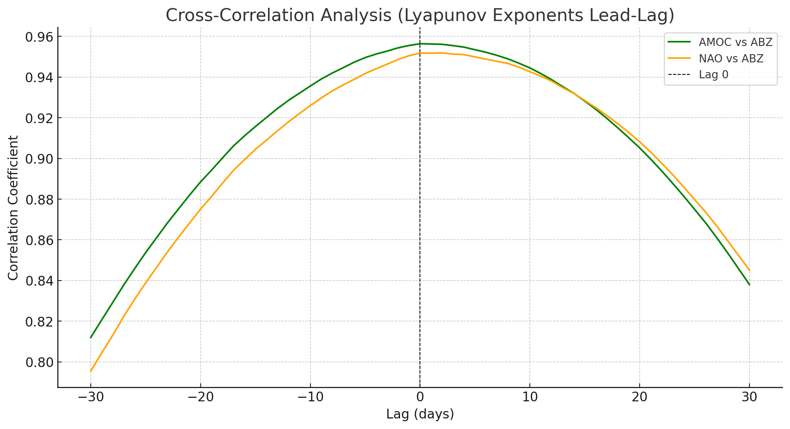
Cross correlation of net radiative flux fractal analysis with Aberdeenshire highest correlation at lag zero
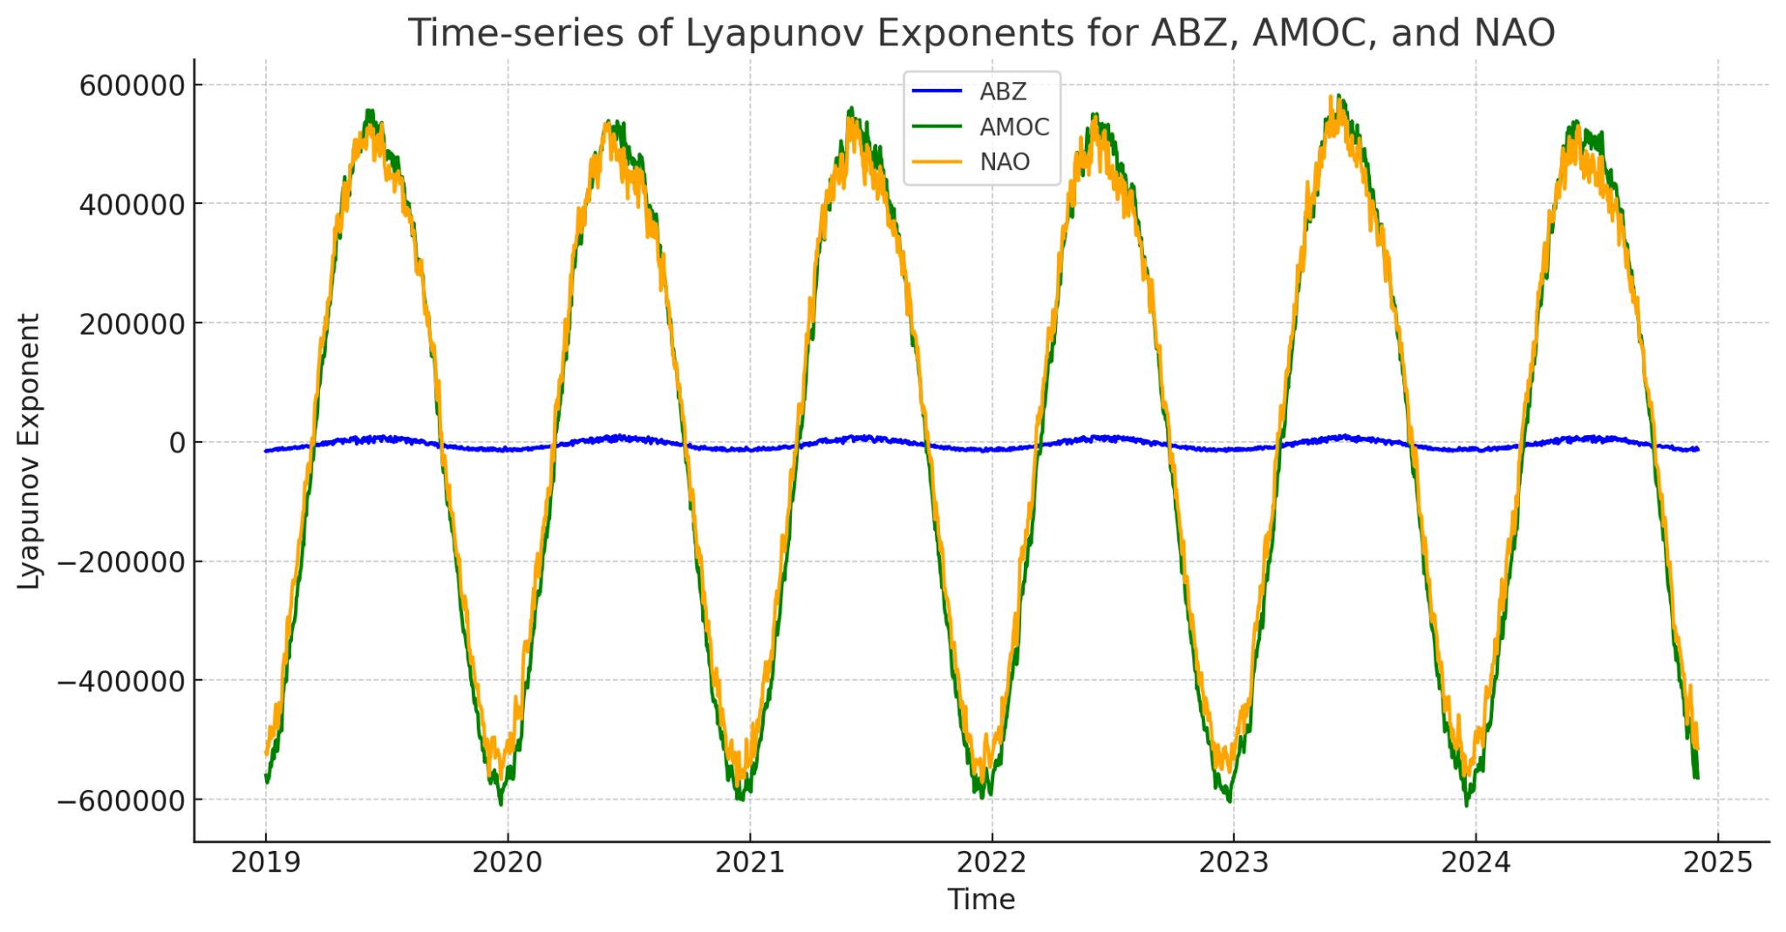
Net Radiative Flux temporal summary showing clear annual seasonality
Temporal analysis of cumulative net radiative flux shows clear seasonality for all three regions. The lower values for Aberdeenshire is because it is a much smaller region. There is a slight kurtosis in the cross correlation which may indicate the presence of a lead/lag relationship between the AMOC/NAO region as a whole, and Aberdeenshire, a much smaller region, although within the larger AMOC/NAO geolocation boundaries.

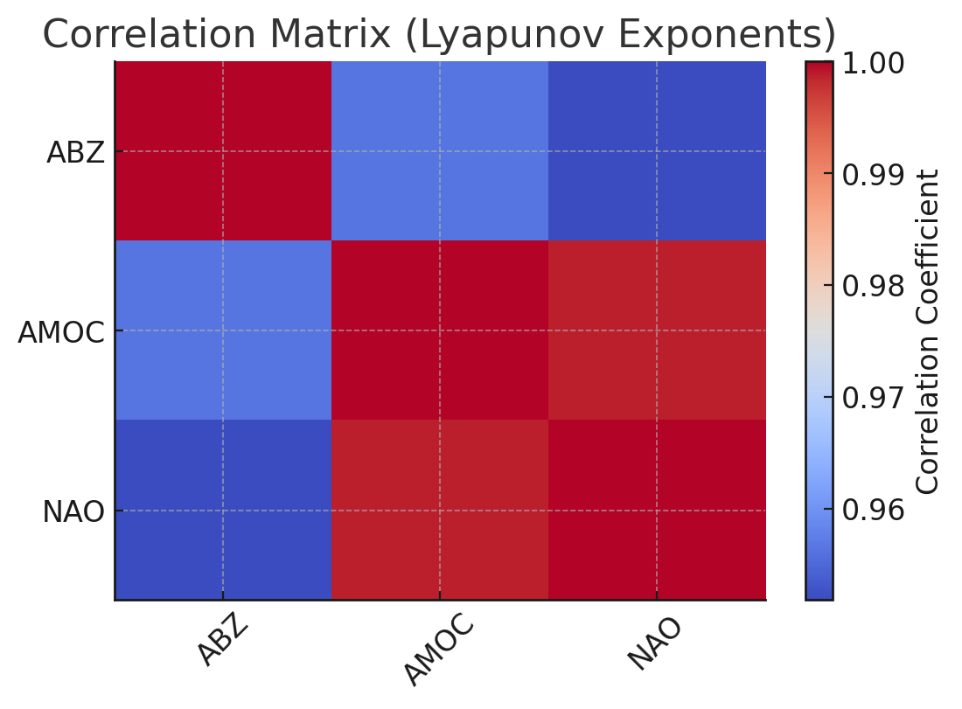
Fractal analysis of Net Radiative Flux High shows correlation coefficients between Aberdeenshire and the AMOC/NAO regions, meaning that Aberdeenshire has the same heat dynamics by spatial location.

Results for Lyapunov Exponents
- Time-Series of Lyapunov Exponents:
  - The AMOC and NAO regions exhibit strong seasonality in their Lyapunov exponents, consistent with global radiative flux dynamics. ABZ has a flatter time-series but shows similar variation, reflecting its smaller geospatial footprint.
- Correlation Matrix for Lyapunov Exponents:
  - The correlation between ABZ and AMOC is 0.956, and between ABZ and NAO is 0.952.
  - AMOC and NAO regions have a large area of overlapping geography.
  - Aberdeenshire is a small geofence within the boundaries of both AMOC and NAO regions.
- Cross-Correlation (Lead-Lag Analysis):
  - The peak correlations for both AMOC vs. ABZ and NAO vs. ABZ occur around Lag 0, indicating near-synchronous instabilities, meaning that net radiation flux behaves similarly throughout the region.
  - Correlation decreases symmetrically as the lag increases, suggesting that changes in AMOC and NAO are closely tied to Aberdeenshire in real-time.

Key Observations
- The strong correlation of Lyapunov exponents across the regions indicates that global weather is interconnected, suggesting that heat at the top of the atmosphere shows distributed instability across regions. It may be that heat distribution is faster where the atmosphere is thinner (less dense).
- Seasonal patterns in AMOC and NAO highlight their role as drivers of global and regional instability.
- The observed kurtosis (skewness, suggesting a weighting) in the correlation for instability between AMOC/NAO regions and Aberdeenshire might indicate specific periods where AMOC/NAO instability has a higher-than-usual impact on ABZ windspeeds. This may indicate that there may be an underlying pattern that changes regularly. Further investigation may reveal the relationship, particularly at the increasing inverse correlation at its maximum extent between 10 and 20 days.

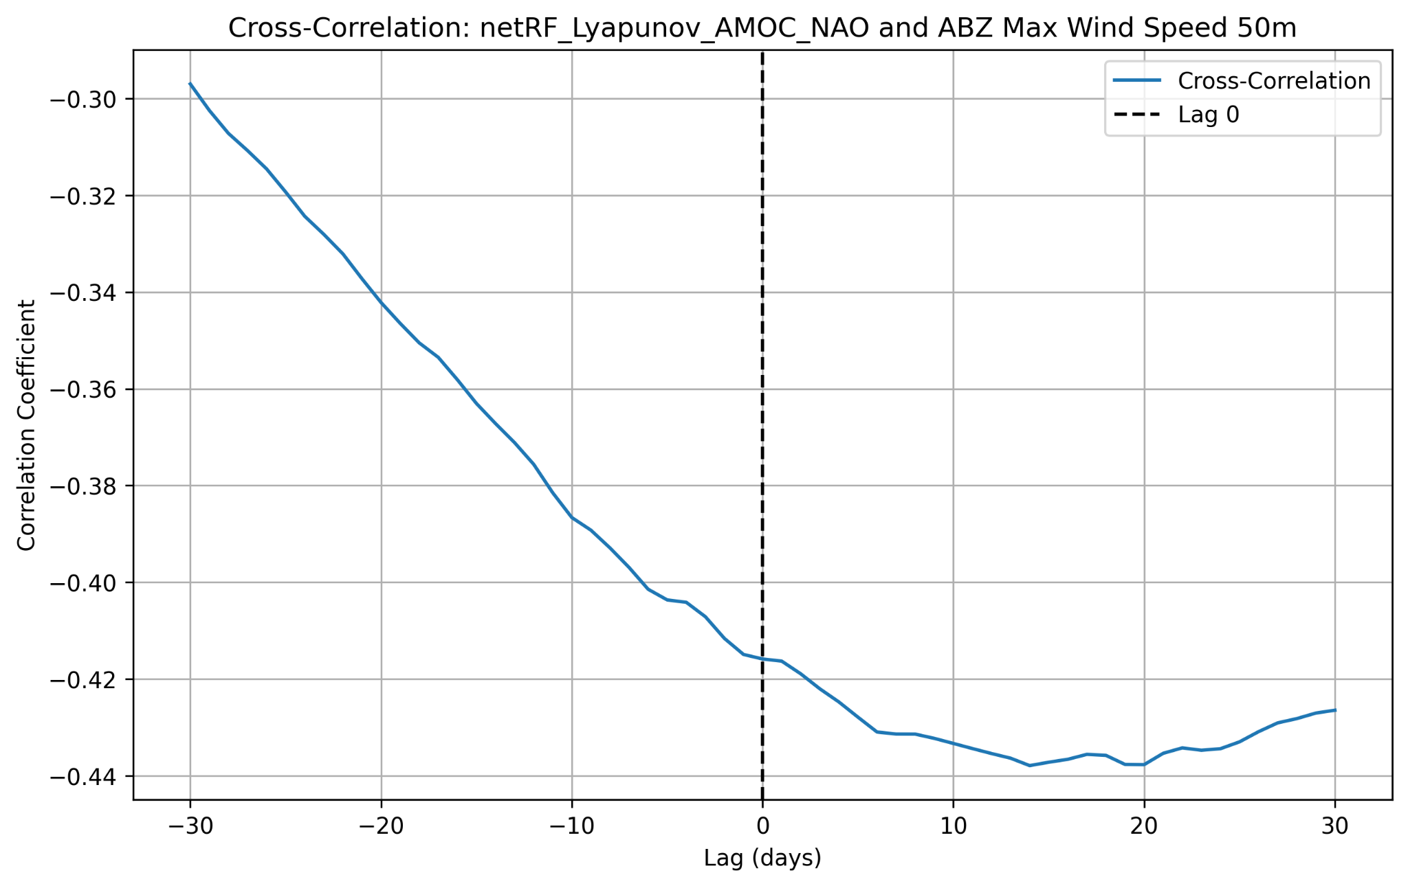
Cross correlation analysis of net radiative flux instability on Aberdeenshire windspeeds at 50 metres.

Weather Variability
The cross-correlation plot between AMOC wind shear and ABZ wind speed at 50m displays a pattern with a possible lag effect (see below). Peaks at −10 days and −20 days suggest that changes in AMOC wind shear might precede ABZ wind speed variations by about 10 to 20 days. Investigation of both net RF instability and high windspeed during the 30 days lag and 30 days lead time might reveal a useful pattern for predicting high winds on closer inspection.

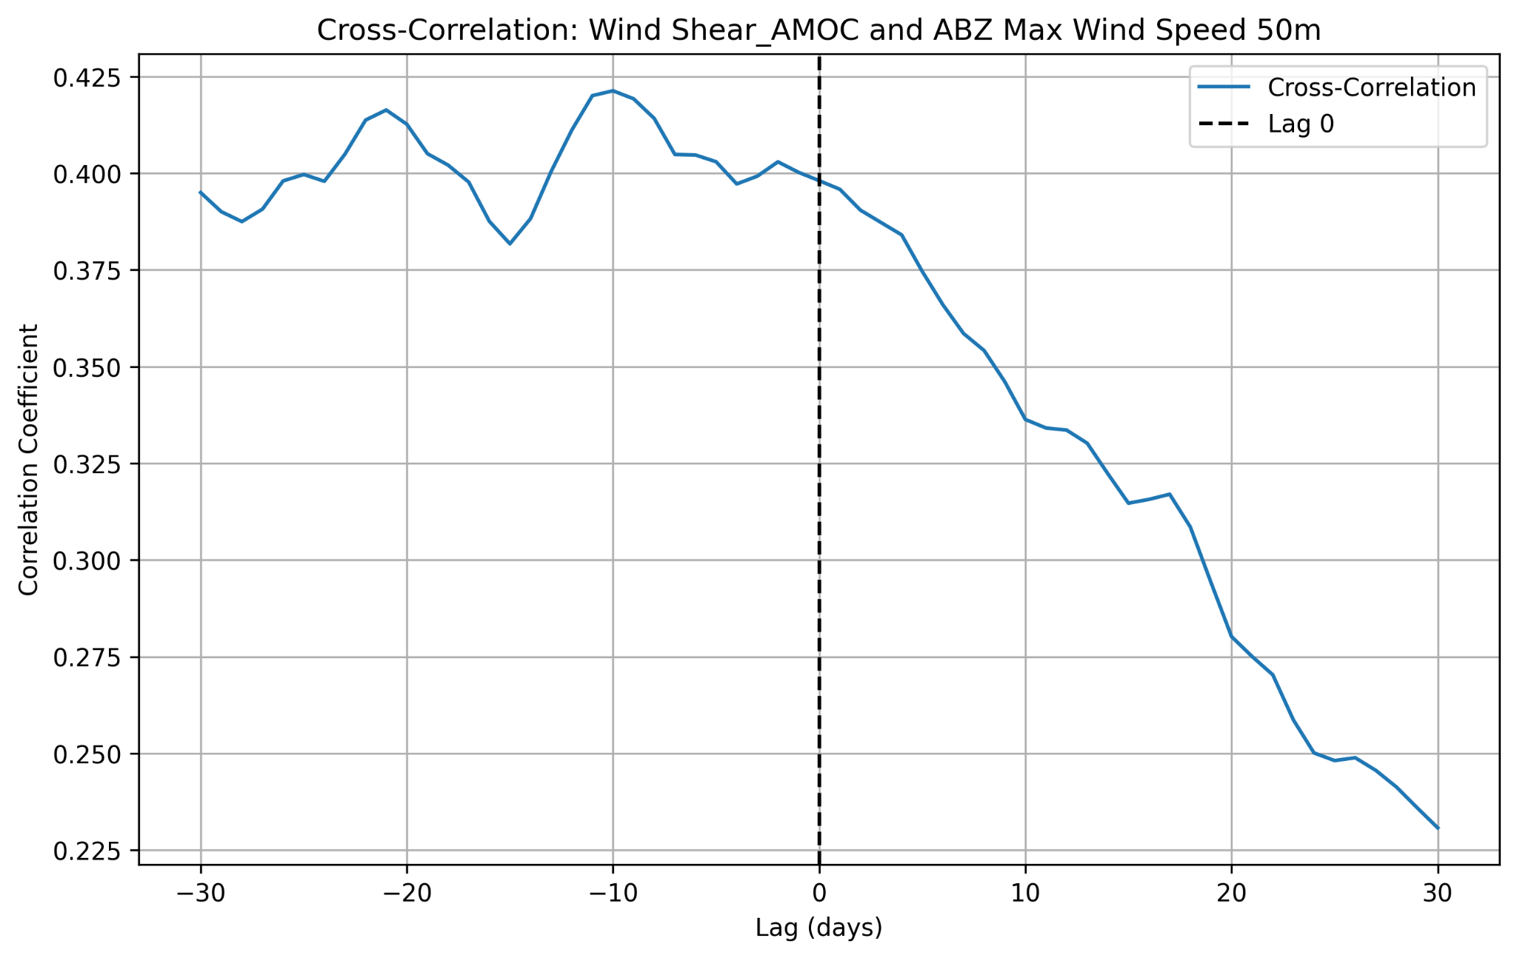
Cross Correlation Analysis of AMOC wind shear and Aberdeenshire Maximum Wind Speed at 50M

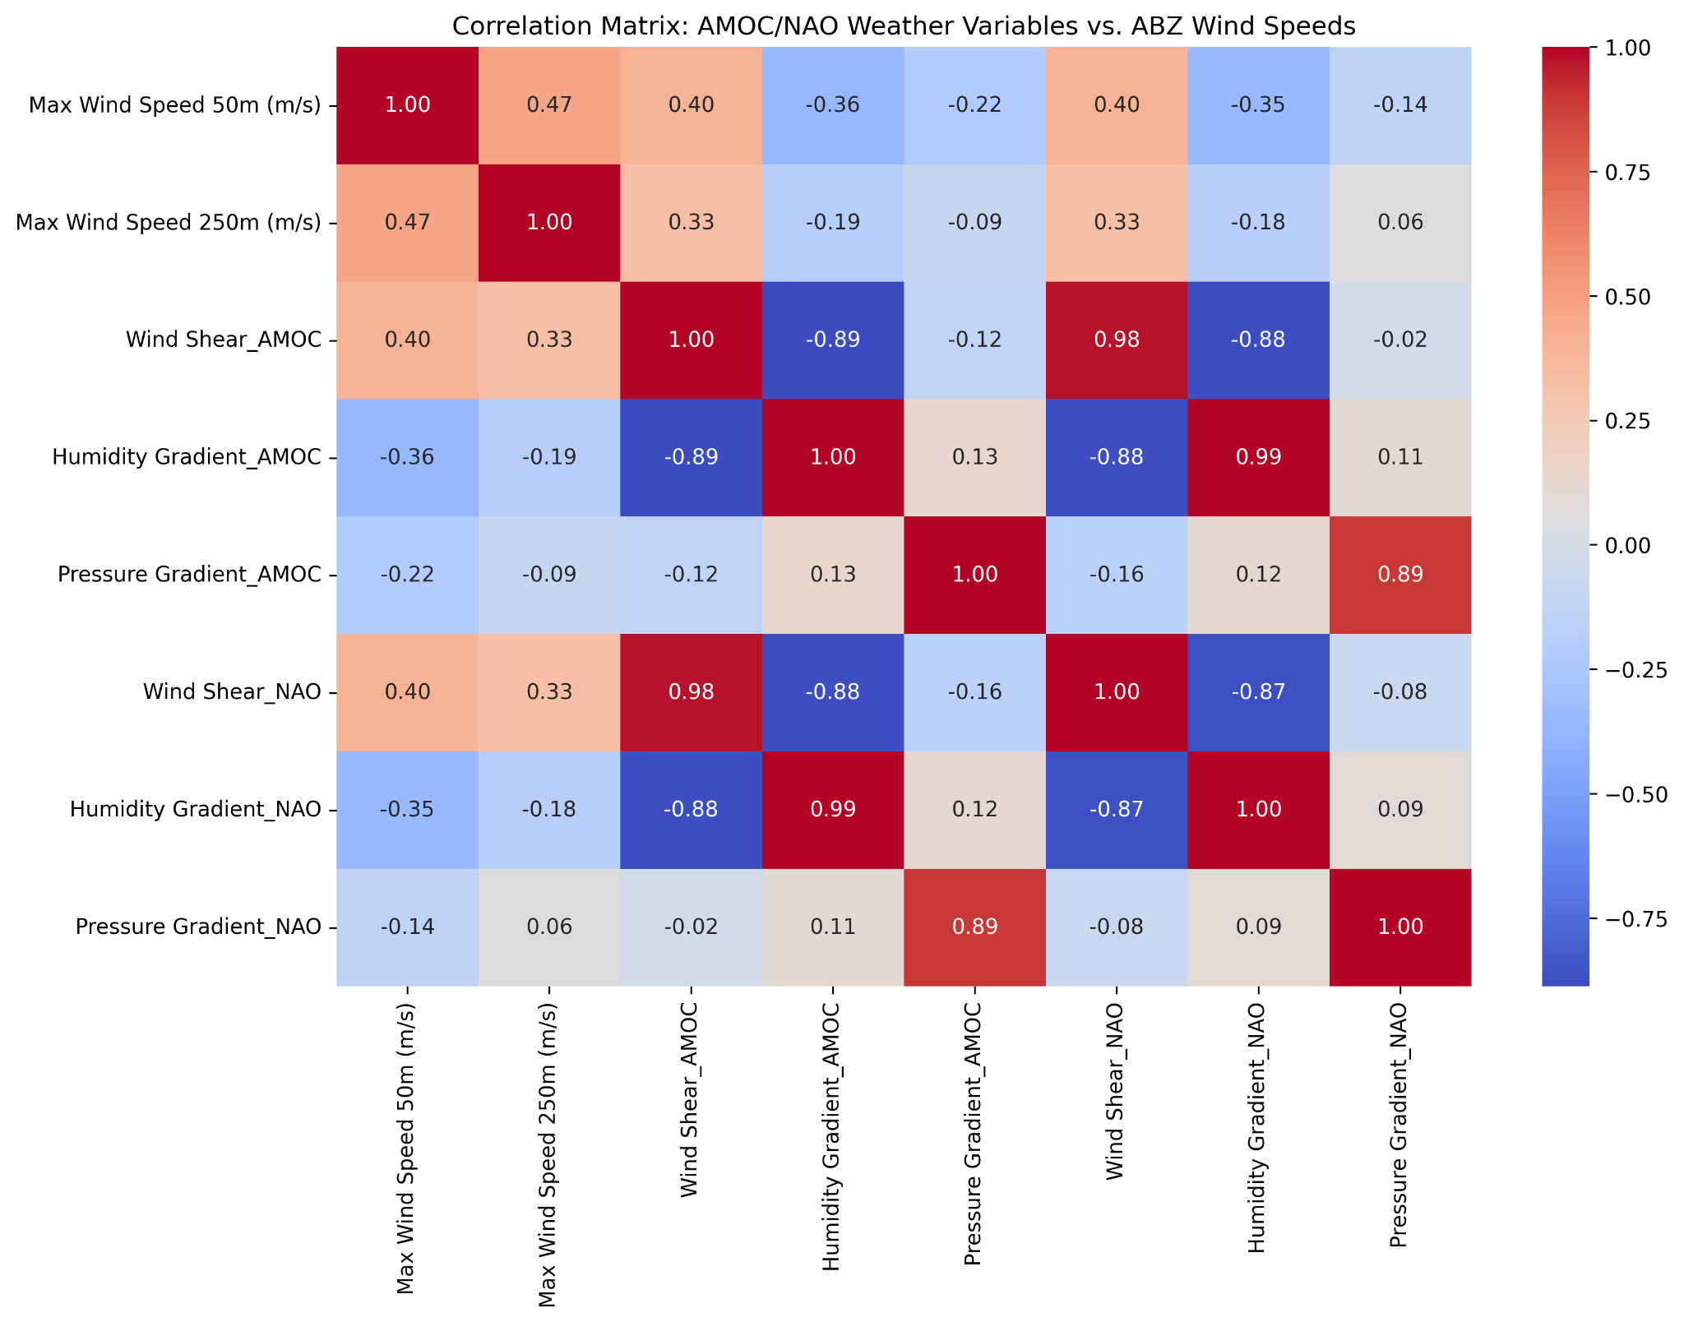
Correlations between AMOC/NAO weather variables and Aberdeenshire maximum wind speeds.

Correlation analysis was performed between AMOC/NAO weather variables such as wind shear, humidity and pressure, and the Aberdeenshire wind speed. The results show notable correlations with both AMOC and NAO variables, such as wind shear (r=0.40) and humidity gradient (r=−0.36). This suggests a possible influence of AMOC/NAO weather patterns on ABZ wind dynamics.

Storm Analysis
Storm analysis of extreme weather events and possible relationships between instability in net Radiative Flux and weather variability in the AMOC/NAO regions and a lead relationship with Aberdeenshire extreme storm weather events was inconclusive. Storm data events were sourced from the UK Bureau of Meteorology (see References).

The hypothesis of Lyapunov Exponents acting as potential lead indicators within three days, for extreme weather events (EWEs) was tested with various statistical methods. Overlaps and lead indicators between Lyapunov Exponents and Extreme Weather Events (EWEs) suggest there might be some value in pursuing this further. While the values of Lyapunov Exponents for EWE leads and overlaps appear higher than average, t-test and chi-squared statistical tests indicated that the lead indicators of up to three days were no better than random chance. Time-lagged and cluster analysis respectively did not produce meaningful results.

However, as subsequent cross-correlation analysis seems to indicate that the most likely lead factors occur between 10 and 20 days, which was not tested for, leaves this analysis inconclusive.

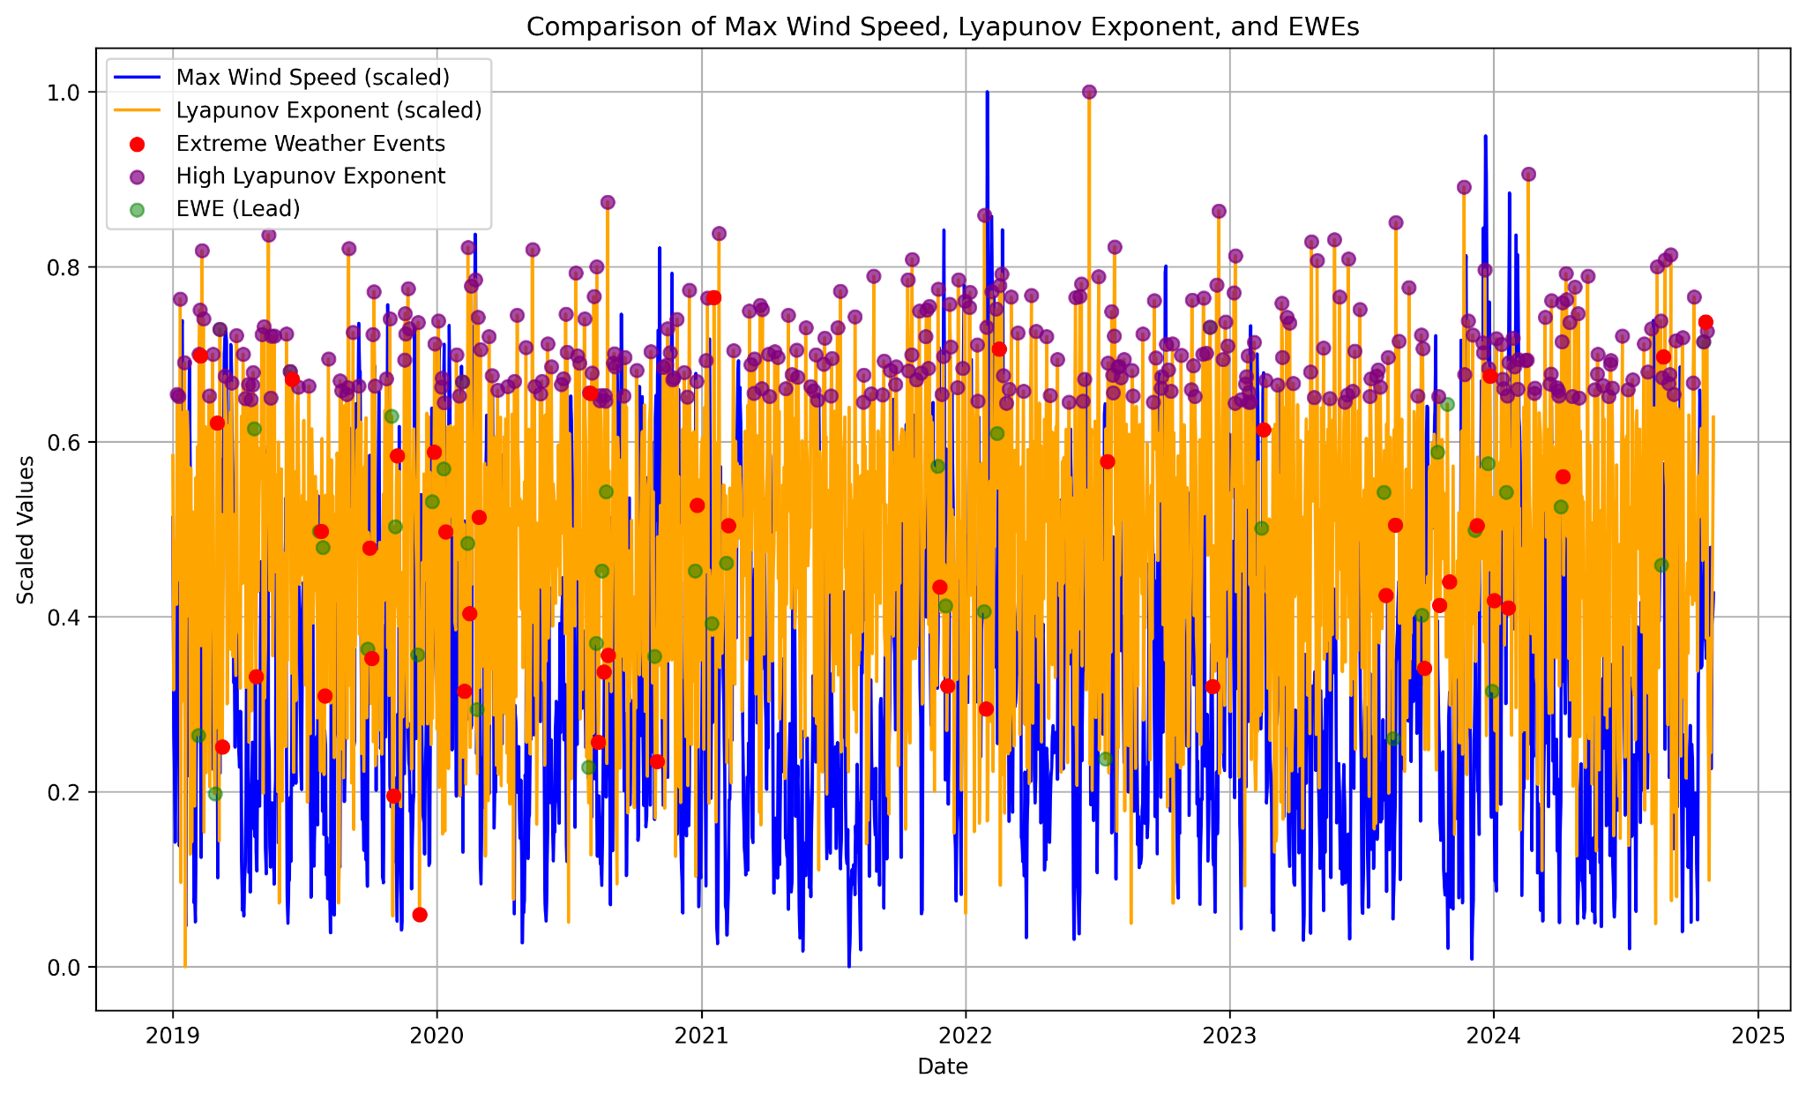
Scaled plot of Aberdeenshire Maximum Wind Speed (50M) and Radiative Flux Lyapunov Exponents

Three day lead dates of daily net RF Lyapunov Exponents in AMOC/NAO regions correlated with extreme storm weather events in Scotland did not produce a close coefficient of correlation. Visual inspection indicates that there may be a relationship. Investigation of longer time frame of lead/lags, perhaps plus or minus 30 days, may be useful.

High Wind Geofence Analysis

High Wind measurements in AMOC/NAO were filtered to > 90th percentile. Focusing on higher windspeeds was intended to gain an insight into individual contributions and correlation with Aberdeenshire windspeeds. Interestingly it appears that all geofences are represented in the top 10% of windspeeds.

Data was aggregated by date to produce an overview of the relationship between high winds in AMOC/NAO super region and Aberdeenshire winds > 20 m/s. The results may show that there is a low correlation of wind shear about 8 days lead, then a high correlation of 2 days lead. The possibility that this may be an identifiable pattern led to performing analysis stratified by season.

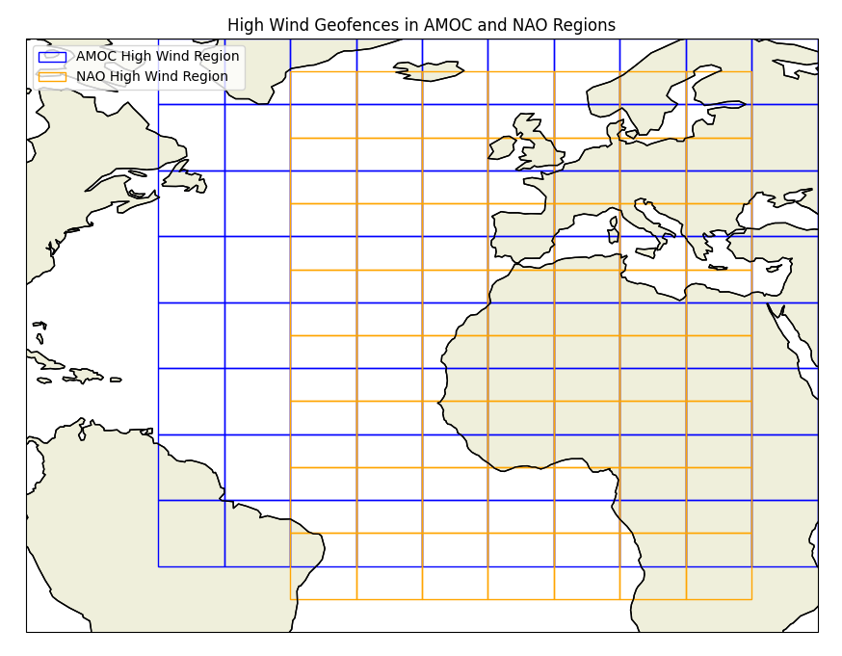
AMOC and NAO high wind regions mapped geographically.

Cross correlation of data filtered to high wind readings produces an interesting picture of the super regions to Aberdeenshire, indicating the changes in correlation may be influenced by seasonality.
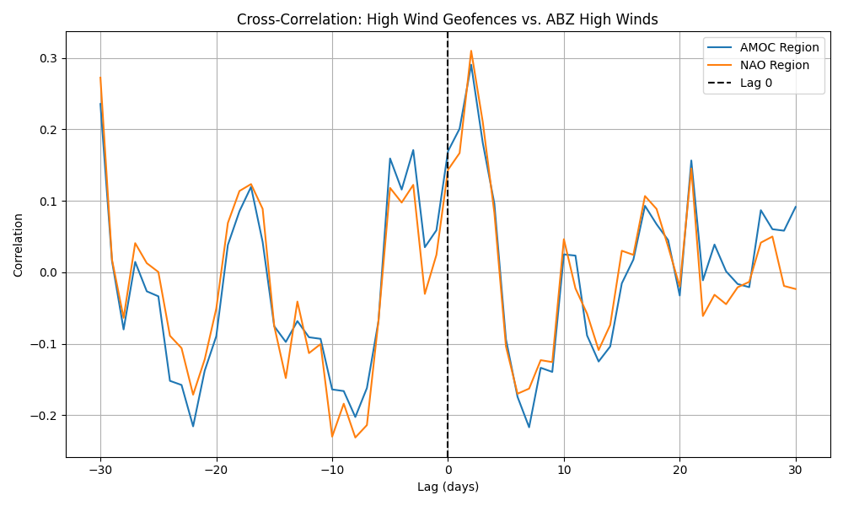
Analysis of high wind geofences in AMOC and NAO regions correlated with high winds in Aberdeenshire

Seasonal influences indeed appear interesting. The extreme variability in summer correlations (swinging between +1 and -1) suggests dynamic and possibly localized weather patterns in the AMOC/NAO regions, which may interact differently with Aberdeenshire winds during this season. The seasonal patterns may be worth exploring in greater depth.

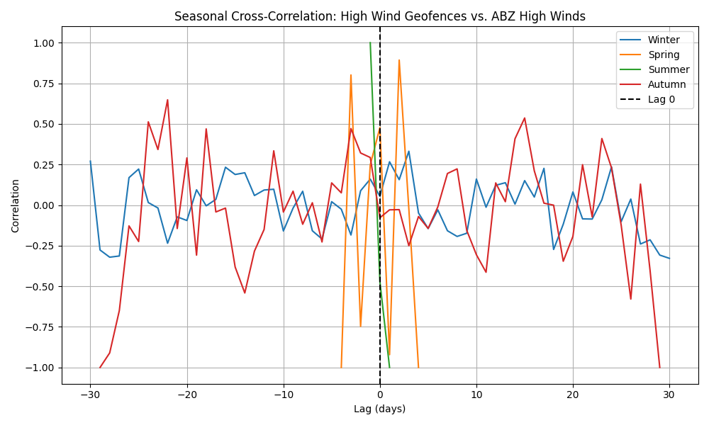,
Cross correlation seasonal analysis of high wind AMOC/NAO Geofences affecting Aberdeenshire high winds.

Findings
There are physical principles and relationships between net radiative flux (netRF), atmospheric instability, and storm dynamics.

NetRF as a Proxy for Heat and Storm Potential
- NetRF, calculated as the difference between Top of Atmosphere Net Shortwave Downward Flux and Upward Welling Longwave Flux, is a direct measure of the energy balance and heat flux. Storm activity is fundamentally driven by energy imbalances in the atmosphere, where netRF contributes to regional heating and cooling. Heat drives convection, evaporation, and pressure gradients—all prerequisites for storm genesis.
- Examining cumulative netRF for the NAO and AMOC regions was undertaken because the goal is to capture the integrated effects of heat buildup over time. Further investigation may help to identify whether prolonged periods of high netRF correspond to increased atmospheric instability and storm activity patterns at the seasonal level.

Lyapunov Exponents as Indicators of Instability

- The proposition that clusters of high netRF Lyapunov Exponents is a proxy for heat-driven instability remains unproven, although the analysis is not conclusive, as netRF instability, as measured by Lyapunov exponents, does not act as a lead factor within three days of storm events in Aberdeenshire. Initial cross correlation analysis raises the question of an inverse relationship, perhaps meriting further investigation in tandem with deeper seasonal analysis of wind patterns.
- Lyapunov exponents measure sensitivity to initial conditions, a hallmark of chaotic systems like weather and climate. High Lyapunov exponents suggest increasing instability and greater divergence of trajectories in the system’s state space. Indications are that there are secondary effects from instability that require time to evolve, allowing instabilities in heat and pressure gradients to propagate and trigger storm formation. A closer view may identify the patterns and the lead/lag times.
- Atmospheric systems are highly dynamic, and heat-driven instabilities may take some time to manifest as storm activity. There are some interesting indications, for example, there is a very close correlation between the instability of net radiative flux at the top of the atmosphere between the disaggregated AMOC/NAO geolocation boundaries and the Aberdeenshire geofence.
- Lyapunov instability may have a much more complex relationship with storm activity generated in the AMOC/NAO regions which affect the UK and Aberdeenshire. The indications are that inverse changes in net radiative flux may be longer term indicators with high winds in Aberdeenshire, and that there are intrinsic changes in instability that may surprisingly be lead indicators of high wind activity. This is worth further investigation, as heat imbalances must generate enough energy to overcome atmospheric resistance (e.g., inertia, Coriolis force) before storms can develop.

Storm Movement
Storms move due to interactions between
- Regional Pressure Gradients: Air moves from high to low pressure, driven by the gradient force.
- Coriolis Effect: Rotational forces on Earth deflect air masses, causing storms to rotate and move in specific paths (e.g., west-to-east in mid-latitudes).
- Jet Streams: These high-altitude winds often steer storms along their paths.
- Thermodynamics: The availability of latent heat from condensation provides energy for storm intensification and motion.
If NAO and AMOC regions are generating instabilities in heat distribution, they could create or amplify weather conditions that propagate storms toward the UK, however it is clear that there is a complex relationship that requires deeper analysis to detect early signs of storm activity from net radiative flux instability. Of course it would be advantageous to have early warnings of the changing weather patterns.

For Further Investigation

Instability Signals
It appears that there is a clear correlation between signals of instability in net Radiative Flux in the AMOC/NAO regions and Aberdeenshire in near real-time. Lyapunov Exponent analysis was conducted over five years of daily data disaggregated over a 10 x 10 degree geofence for each of the AMOC and NAO regions, and over the whole Aberdeenshire region (approx 2 x 2 degrees).

Apply Clustering or Dimensionality Reduction
Use of clustering or Principal Component Analysis (PCA) to identify patterns or latent variables in the AMOC/NAO data might further explain the lead/lag wind and net radiative flux relationships with ABZ wind dynamics.

Call to Action
In view of Scotland's ambitious climate change legislation with a target date for net zero emissions of all greenhouse gases by 2045, Renewable Energy transition stabilisation is of critical importance. Extreme weather events are now more frequent and less predictable. For instance, effects of the recent Storm Ashley were particularly felt in Scotland in October 2024. The storm was accompanied by strong winds, large waves and treacherous conditions at sea. As predicted for climate change, extreme weather events are set to increase, including large storm surges affecting coastal areas. Any efforts we make collectively, to understand changing weather patterns with a view to improving early warnings, are important contributions to extending our knowledge and understanding of how we can address uncertain future changes in climatic conditions.

Terminology

Term | Clarification
Net radiative flux | Net radiative flux in this context refers to SWTNT - LWTUP calculated at an hourly resolution by lat lon boundary as defined in NASA MERRA2. It is used as a proxy for global heating subset by geographic boundaries related to the AMOC and the ENSO respectively.
NASA MERRA-2 Data | The Modern-Era Retrospective analysis for Research and Applications, Version 2 (MERRA-2) provides data beginning in 1980. It was introduced to replace the original MERRA dataset because of the advances made in the assimilation system that enable assimilation of modern hyperspectral radiance and microwave observations, along with GPS-Radio Occultation datasets.
AMOC | The Atlantic meridional overturning circulation (AMOC) is the main ocean current system in the Atlantic Ocean. It is a component of Earth's ocean circulation system and plays an important role in the climate system. The AMOC includes Atlantic currents at the surface and at great depths that are driven by changes in weather, temperature and salinity.
NAO | The North Atlantic Oscillation (NAO) index is based on the surface sea-level pressure difference between the Subtropical (Azores) High and the Subpolar Low. The positive phase of the NAO reflects below-normal heights and pressure across the high latitudes of the North Atlantic and above-normal heights and pressure over the central North Atlantic, the eastern United States and western Europe. The negative phase reflects an opposite pattern of height and pressure anomalies over these regions.
Lyapunov Exponent | The Lyapunov Exponent is used to measure the degree of contraction or divergence with different initial conditions over time according to the exponential law, and the ratio of convergence or divergence of trajectories. It is an indicator of deterministic chaos. Values < 0 means it is a converged dynamical system to a stable fixed point. = 0 means it is a limit cycle, the dynamical system is stable. If > 0 means it is an unstable dynamical system with chaotic behaviour. (The Lyapunov Exponent quantifies and verifies the sensitive dependency to initial conditions and the stability of equilibrium in dynamical systems by analysing the non-linear divergence or convergence of trajectories. Phase space dimensions indicate the possible states.)
Fractal Analysis | Fractal analysis is a mathematical approach used to study complex, self-similar patterns that are often found in natural systems. In the context of climate science, fractal analysis can be applied to detect early warning signals of approaching tipping points. As a system nears a tipping point, its behavior may exhibit characteristic changes, such as increased variability and autocorrelation, which are indicative of critical transitions. Fractal analysis helps in identifying these patterns by examining the scaling properties and temporal correlations within climate data.

References
NASA MERRA-2 Data Source Information
https://gmao.gsfc.nasa.gov/pubs/docs/Collow1253.pdf
UK Met Office Past Weather Events
https://www.metoffice.gov.uk/weather/learn-about/past-uk-weather-events
Trac-Car OpenAI Fractal Analysis of Net Radiative Flux https://trac-car.com/Fractal%20Analysis%20of%20Net%20Radiative%20Flux.pdf
Nolds Lyapunov Analysis Documentation
https://nolds.readthedocs.io/_/downloads/en/0.5.2/pdf/

Appendix A - Renewable Energy Microgrid Use Case
The following workflow applies to a hypothetical scenario for a renewable energy Microgrid for the Port of Aberdeen. Further investigation of the predictability of wind speeds in Aberdeenshire could provide the certainty for the complex dynamics involved in building renewable energy microgrids that serve the transition to net zero emissions, with stable energy generation using Fractal Analysis and Explainable AI (XAI)

Scenario: Port of Aberdeen Electricity Generation
Develop a collaboration with the Port of Aberdeen and its stakeholders to incorporate a hydrogen hub and solar arrays into a microgrid primarily powered by wind turbines, emphasizing operational needs for port facilities.

- Primary Source:
Offshore wind turbines for primary renewable energy generation.
Solar arrays as an additional renewable source, tied to a hydrogen production facility.
- Storage:
Green hydrogen storage systems powered by both wind and solar energy, enabling large-scale energy storage.
Advanced hydrogen electrolyzers integrated with the solar facility for scalable hydrogen production.
- Backup:
Inshore and land-based turbines to provide secondary backup.
Smaller, distributed renewable energy sources (e.g., tidal or small-scale solar) as tertiary support.
- Failover Controller:
Predictive fractal analysis-based failover system that forecasts supply-demand gaps and proactively initiates backup systems.
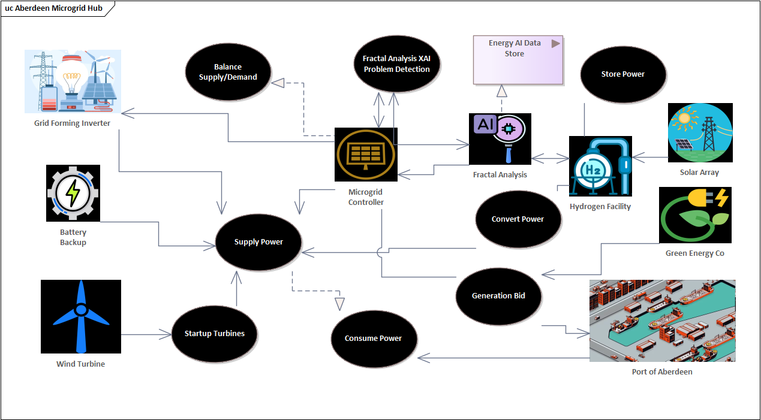
Scenario for a renewable energy microgrid with the Port of Aberdeen
Solar Hydrogen Facility Integration: A hydrogen hub project as a primary storage and failover mechanism.
Scenario Development:
- Design the microgrid to simulate real-world port operations, powering cranes, ships, and auxiliary services with renewable energy.
- Highlight the ability to balance renewable energy intermittency with robust storage solutions.

Input:
- Offshore wind and solar generation feed directly into the energy grid and hydrogen production facility.
- Green hydrogen production serves both storage and direct supply to heavy industry or port operations
Storage and Supply:
- Hydrogen is stored for both long-term energy stability and immediate usage during generation dips.
- Renewable sources feed excess energy into the grid or directly into hydrogen production.
Failover Actions:
- Predictive analysis using weather, fractal patterns, and explainable AI to forecast energy shortages or grid instability.
- Backup generation activates when triggered, prioritizing hydrogen systems for stability
Energy Synergies: Combining solar arrays with offshore wind to create a more resilient energy mix.
- Hydrogen Applications: Powering both the port infrastructure and auxiliary services, showcasing hydrogen's versatility.
- Economic Case: Using the port as a high-profile example to validate the economic and operational feasibility of renewable microgrids.

Use Case Prototype Workflow
The workflow could encompass the following features:
- Wind and solar generation as parallel energy inputs.
- Hydrogen storage and failover controls in central nodes.
- Backup generation systems connected to the predictive fractal analysis and explainable AI systems.
- Energy output delivered to port operations and auxiliary consumers.
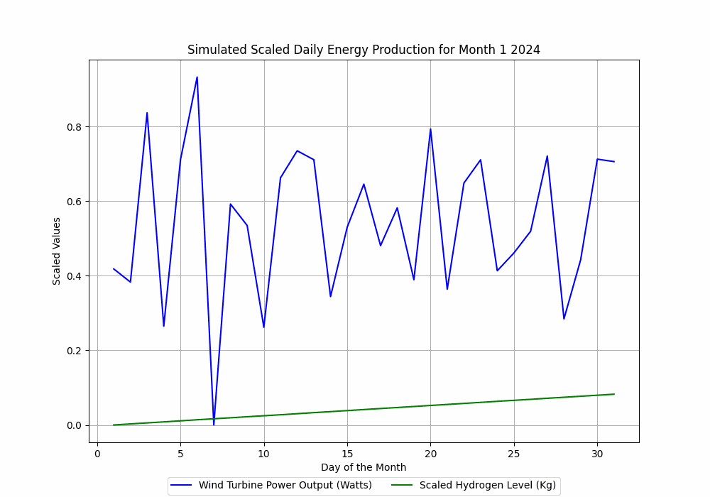
Simulated Renewable Energy, Wind Speed and Forecast Turbulence Aberdeen Port Microhub Scenario
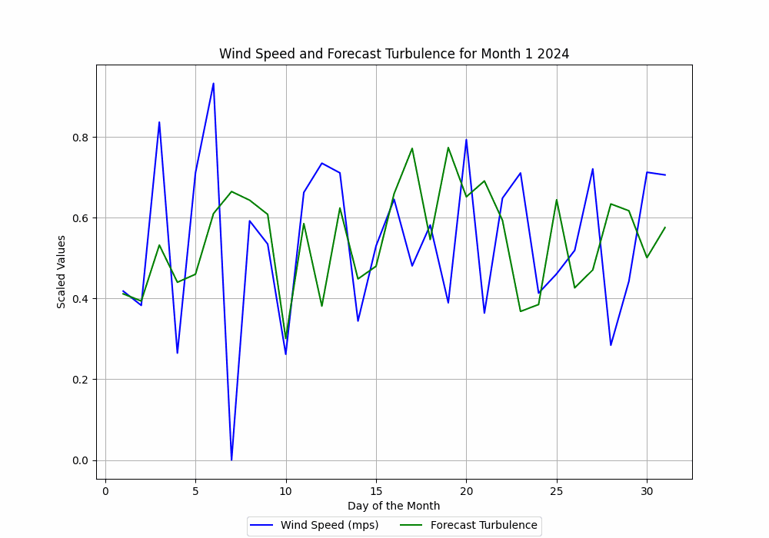
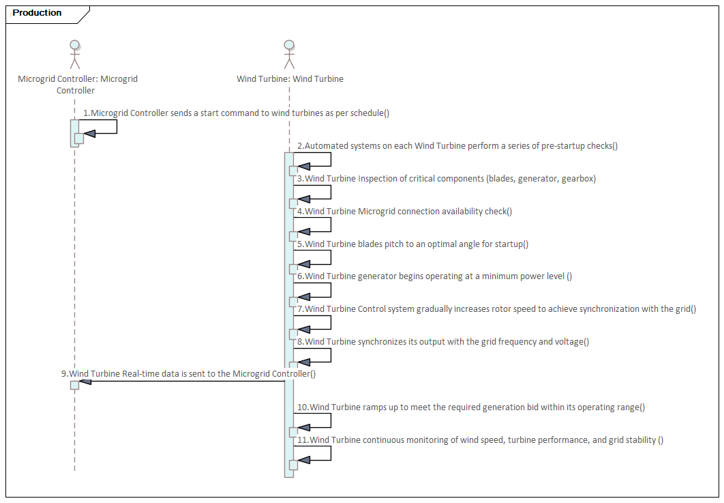
Aberdeen Microhub Ramping Up Production
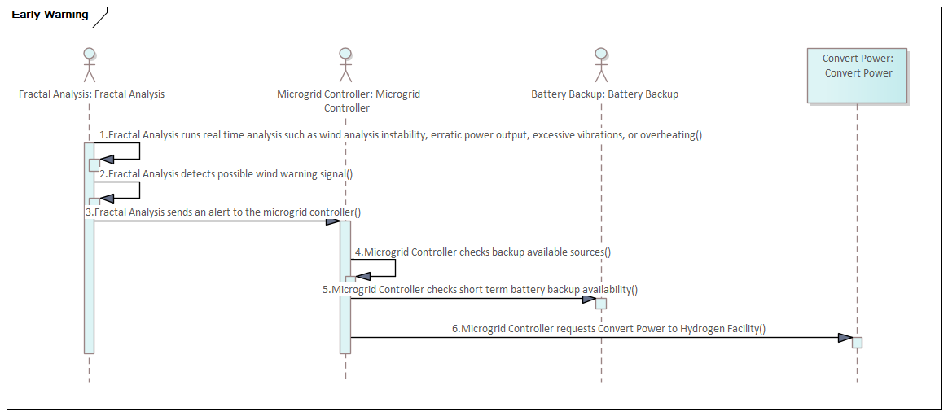
Aberdeen Microhub Early Warning Fractal Analysis and Explainable AI

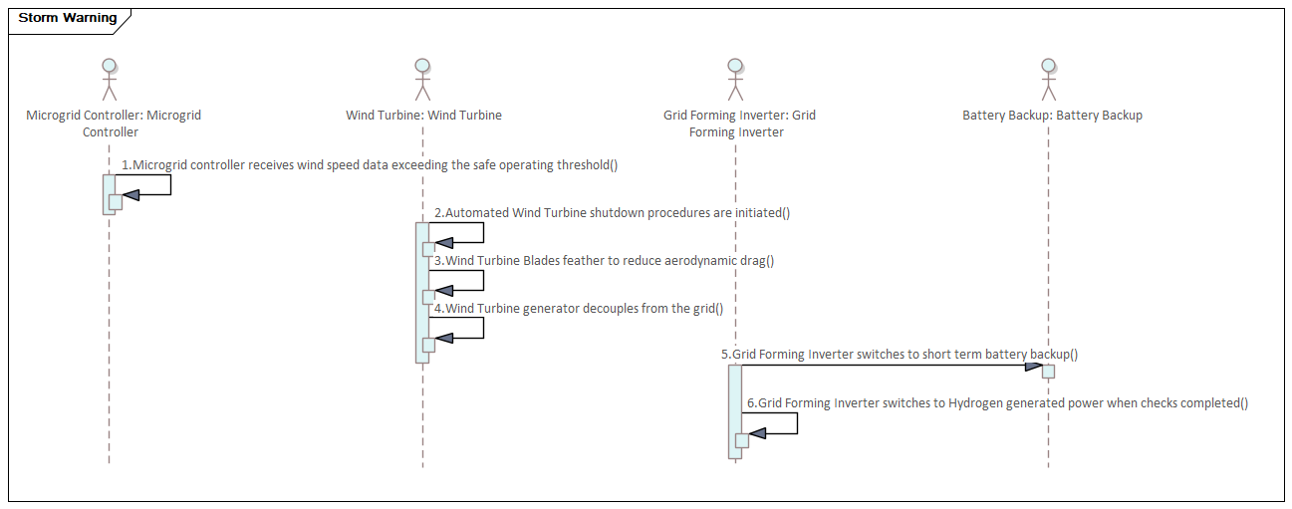

Aberdeen Microhub Responds to Storm Warning

